

Software Engineering Department
Braude College of Engineering
Final Project – Phase B (61999)

Dynamic Labyrinths - Asymmetric Hunter vs. Builder

CODE: 26-1-D-22
By:
Elio Pikuli
Elio.Pikuli@e.braude.ac.il
Maxim Lazarenko
Maxim.Lazarenko@e.braude.ac.il

Advisor:
PhD. Sulamy Moshe
MosheSu@braude.ac.il
Link to GitHub:
https://github.com/ElioPikuli/Dynamic-Labyrinths---Asymmetric-Hunter-vs.-Builder.git

Table of Contents
Abstract 2
1. Introduction 3
2. Development process 4
3. Diagrams 5
3.1. Package Diagram 5
3.2. Activity Diagram 6
4. Screens and Flow 7
5. ML-Agents and training in Unity 12
5.1. Reinforcement Learning 13
6. Problems and Solutions 14
6.1. Decisions 15
6.2. Tools we used 16
7. Results and Conclutions 17
7.1. Further Improvements 18
8. User Manual 19
8.1. Maintenance Guide 21
System Architecture & Operational Environment 21
Core Subsystems & Code Locations 21
Routine Maintenance & Deployment Procedures 22

Abstract

Dynamic Labyrinths - Asymmetric Hunter vs. Builder is an innovative asymmetric multiplayer game designed to bridge the gap between theoretical computer science and interactive entertainment, with a primary focus on the comparative analysis of pathfinding algorithms.
The game operates within a dynamic 3D environment, utilizing a cross-platform architecture to create distinct roles for players. A PC user takes on the role of a collector, navigating a maze to gather puzzle pieces, while a mobile user acts as a strategist, dynamically altering the map's topology to assist autonomous bots in guarding these objectives. This asymmetry creates a constantly shifting landscape, presenting unique challenges for navigation and obstacle avoidance in real-time.
The core technical contribution of the project lies in its post-round analysis and algorithmic comparison engine. Once a round is completed, the system analyzes the final map layout using a suite of different pathfinding algorithms to calculate the theoretically optimal path. The system then presents the player with the specific algorithm that achieved the best performance for that unique map configuration. This educational feedback loop is further enhanced by a replay mode, where players receive real-time decision-making suggestions based on the calculated optimal route, allowing them to visualize algorithmic efficiency in practice.
Developed using modern game development frameworks to support cross-platform synchronization, the application serves as both a competitive experience and a visualization tool. By gamifying the differences between heuristic and non-heuristic search methods, the project aims to provide an intuitive understanding of how different algorithms adapt to complex, dynamic environments.

Introduction
Dynamic Labyrinths - Asymmetric Hunter vs. Builder is a multiplayer strategy game designed to captivate players while providing a unique, fun, and enjoyable approach to visualizing and learning computer science concepts, particularly in the field of pathfinding algorithms and graph theory.
Traditional methods of learning algorithms can sometimes feel abstract and disconnected from practical implementation, relying heavily on static diagrams and pseudocode. By immersing players in a competitive, asymmetric 3D environment where the map itself is variable, Dynamic Labyrinths brings algorithmic logic to life. Through navigating complex mazes and strategically altering the terrain, players gain hands-on experience with fundamental principles such as shortest-path calculation, obstacle avoidance, and heuristic search efficiency.
In Dynamic Labyrinths, players have the unique opportunity to experience the difference between static and dynamic environments in a tangible way. Instead of just analyzing a graph on paper, one player (the Builder) actively alters the map topology in real-time to assist bots to capture the Hunter, while the other (the Hunter) must navigate these changes.
During gameplay, the Hunter makes quick navigation decisions to avoid bots and collect puzzle pieces. They achieve this by learning from post-game analysis and actively incorporating the advantageous suggestions provided by the system’s optimal route calculation during replay modes, ensuring they take the most efficient steps to navigate the maze successfully.
Dynamic Labyrinths goes beyond traditional hide-and-seek gameplay by integrating a comparative analysis engine. This allows us to offer real-time guidance during replays, showing players exactly how specific algorithms would have solved the maze faster. This seamless integration of competitive gameplay and algorithmic visualization ensures that players not only have fun but also develop and refine their understanding of computational efficiency.
Dynamic Labyrinths caters to computer science students, strategy enthusiasts, and anyone seeking an entertaining and educational gaming experience. Whether you're a software engineering student aiming to reinforce your knowledge of search algorithms or simply a gamer with a passion for logic and strategy, this game is designed to fulfill your need for interactive and captivating learning.
All the mentioned above happens while the Hunter frantically collects puzzle pieces to complete the objective, while the mobile player dynamically changes the 3D map to guide guard bots, creating a tense race against the opponent to determine the superior strategist.

Development process
In the development of Dynamic Labyrinths, an asymmetric cross-platform multiplayer game built in Unity, the primary objective was to create an engaging environment for visualizing and comparing advanced 3D pathfinding algorithms. The process began by translating this core concept into a playable cat-and-mouse dynamic between a PC and a mobile device. To handle the required network synchronization, Unity Netcode for GameObjects (NGO) and the Unity Transport Protocol (UTP) were integrated. This allowed the PC to act as the authoritative Host Server while the mobile device connects locally as a Client. Establishing this server-authoritative architecture was critical for preventing desynchronization particularly for logic like the bot capture timer, ensuring that latency on the mobile end would not trigger false game-over states.
Once the networking foundation was stable, the focus shifted to procedural map generation and the underlying artificial intelligence. The environment was engineered to generate entirely different layouts based on grid math, supporting specific algorithmic biomes like the Maze, Caverns, and Arena. Into this grid, autonomous Hunter Bots were introduced using the Unity ML-Agents toolkit. These bots required continuous path calculations, utilizing distance-based reward systems and spatial observations to optimize their hunting behavior. Crucially, the map generator was built to instantly update the master pathfinding grid whenever the topology changed so the bots could adapt instantly.
Finally, the distinct player roles and asymmetric mechanics were programmed. The Hunter (PC Player) was developed with a first-person perspective, utilizing standard keyboard and mouse controls to run, and navigate the labyrinth. To encourage exploration, collectible puzzle coins were scattered across the map, programmed to grant 10+5 seconds of direct path guidance toward the escape point upon collecting five pieces. Conversely, the Builder (Mobile Player) was given an orthographic, top-down perspective with mobile-optimized touch controls for dragging and pinching to zoom. By tapping open tiles, the Builder can instantly drop biome-specific walls into the map, successfully merging rigorous algorithm testing with highly competitive, real-time multiplayer gameplay.

Diagrams

Package Diagram
- Core.Algorithms -> Core.GridSystem
(The Algorithms need access to the Nodes to calculate costs.)
- Systems.Networking -> Core.GridSystem
(The Network needs to sync the Grid state between players.)
- UI.Visualization -> Core.GridSystem
(The UI needs to read the Grid to know where to draw walls.)
- Systems.AI -> Core.GridSystem
(The AI needs to "observe" the Grid to decide where to move.)
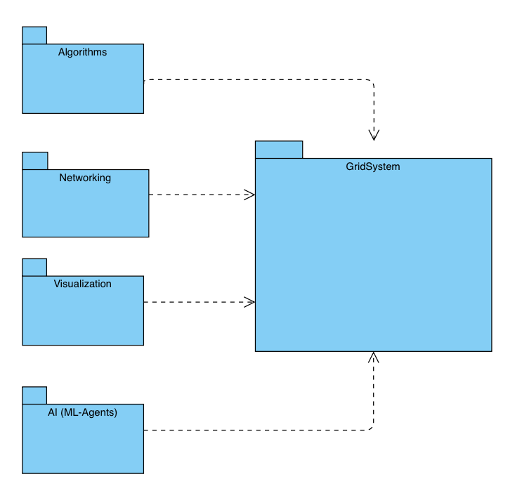

Activity Diagram
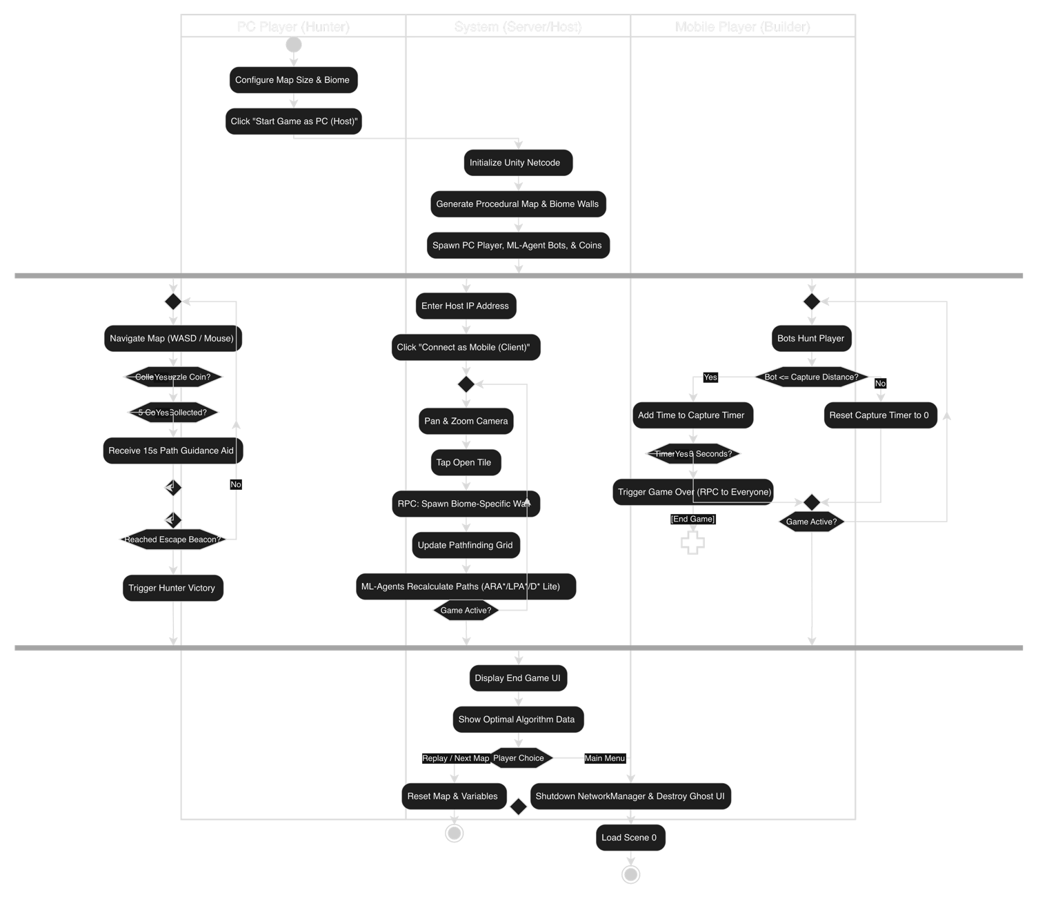

Screens and Flow
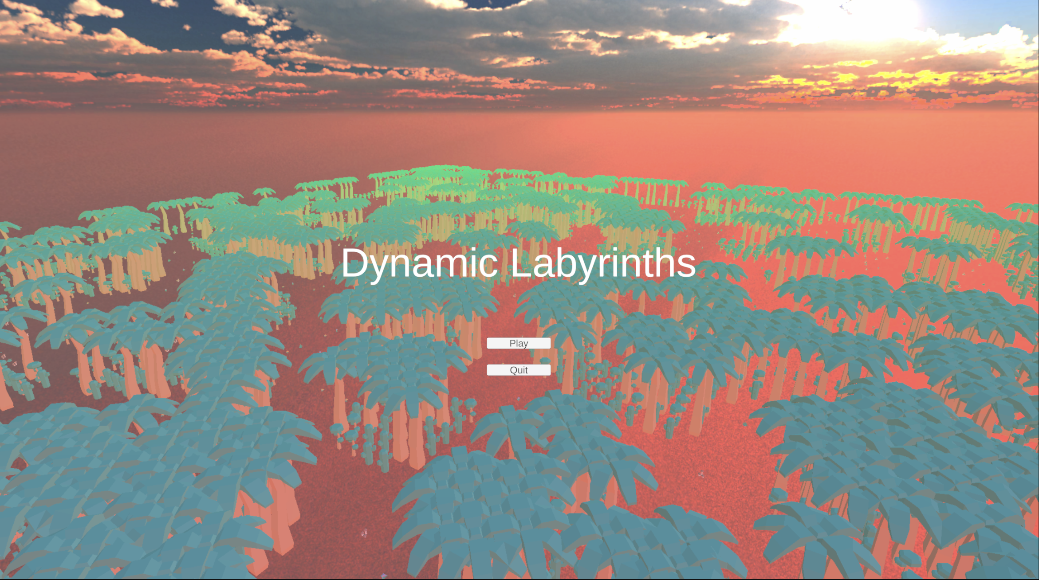
Home Screen:

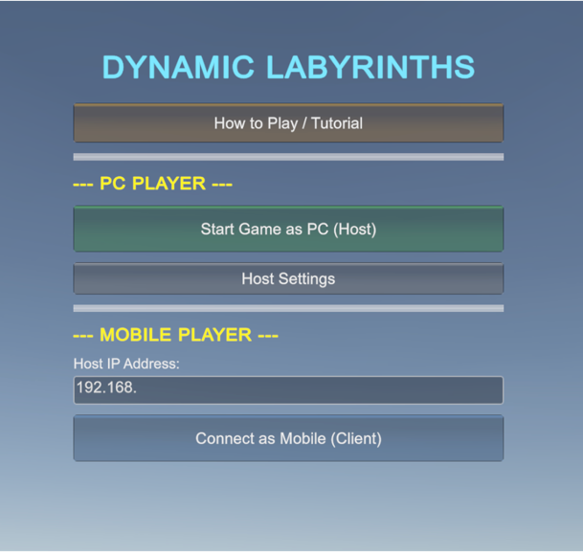
Start Screen:

The "PC Player" section handles server hosting and configuration, while the "Mobile Player" section provides a streamlined client connection interface.
Local Network Integration: The mobile section includes a dedicated text input field for the Host IP Address, allowing the mobile device (Client) to handshake with the PC (Server) over a local Wi-Fi connection via Unity Netcode.

How to Play:
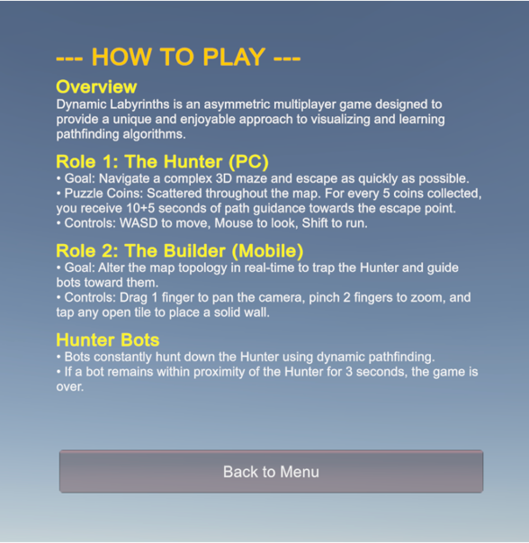

A dedicated, scrollable onboarding screen that explains the unique mechanics of the game

Host Settings:
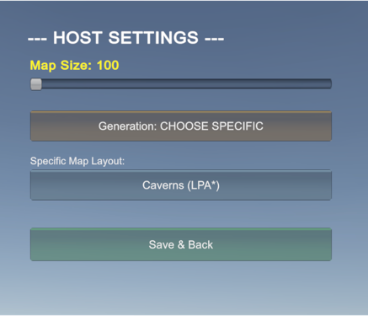
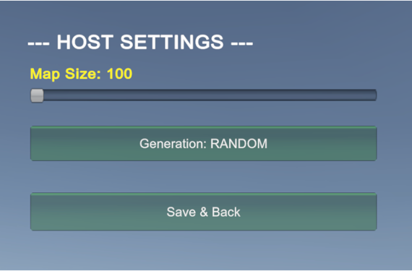

A UI slider allows the Host to dynamically adjust the scale of the procedural grid, directly influencing the complexity and duration of the upcoming match.
The Host can toggle between "Generation: RANDOM" and "Generation: CHOOSE SPECIFIC". When specific generation is selected, the Host can cycle through dedicated layouts.

Gameplay:
End Level:
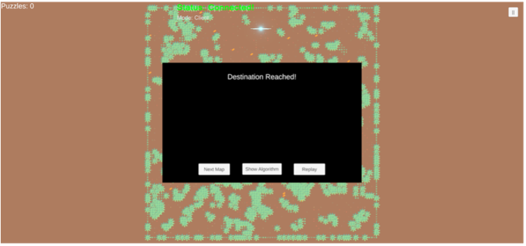
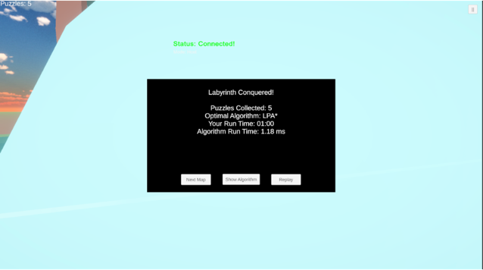
PC Mobile

Host Analytics: When the Hunter reaches the beacon, the PC displays a detailed "Labyrinth Conquered!" screen. This serves as the core analytical readout for the project, comparing the player's run time against the optimal algorithm's execution time.
Client Notification: The mobile Builder receives a simplified "Destination Reached!" alert, notifying them that the Hunter successfully escaped.

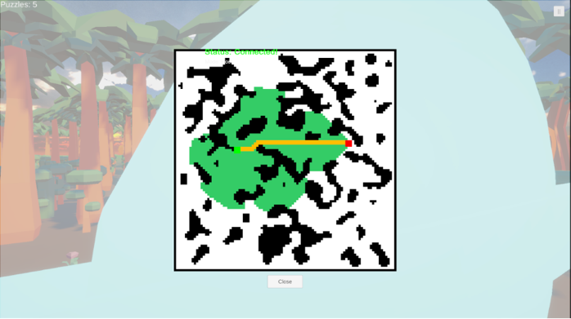
Algorithm showcase:

Triggered by the "Show Algorithm" button, this overlay displays a real-time 2D grid representation of the labyrinth's topology.
Visualizes the internal math of the pathfinding algorithms, mapping the start point to the end point via the most efficient calculated path.
Provides a clear view of how the obstacles restrict movement, allowing the players to review the effectiveness of the Builder's wall placement.

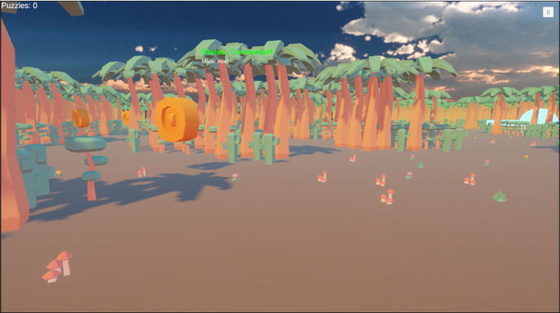
Puzzle collection:
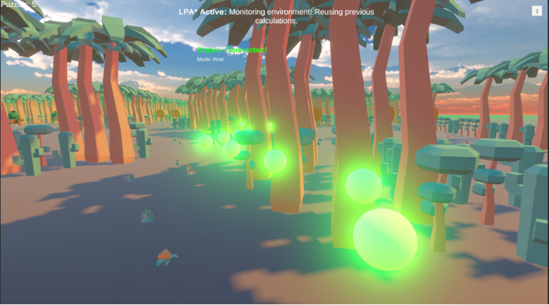
Collection: Floating puzzle coins are scattered throughout the 3D environment to encourage exploration by the PC Hunter. The top-left HUD tracks the player's current inventory.
Path Guidance Aid: Upon collecting 5 coins, a glowing green trail of spheres activates, providing direct visual guidance toward the escape beacon.

Captured Screen:
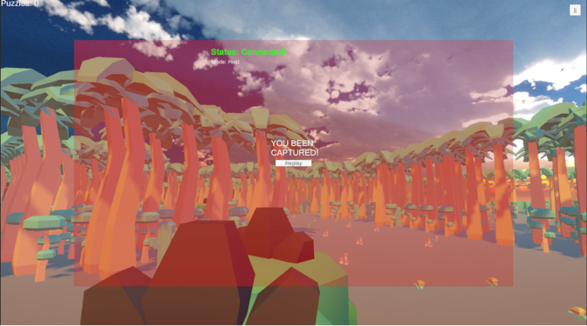
PC Mobile
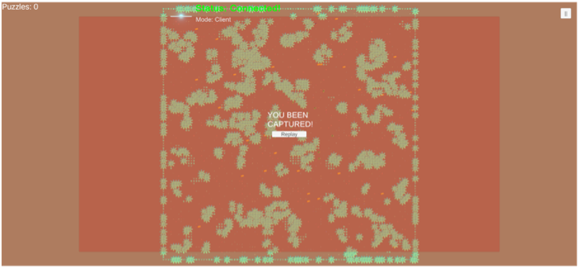
PC Perspective: When the Hunter Bots maintain proximity for 3 seconds, a red "YOU BEEN CAPTURED!" overlay dominates the first-person screen.
Mobile Perspective: Synchronized via Unity Netcode, the mobile device receives the Game Over RPC and displays an identical red failure state.

Pause Screen:
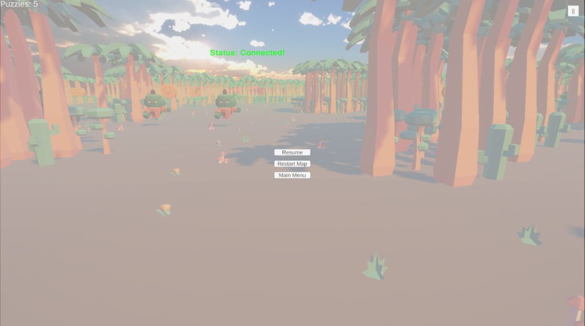

Features standard navigation options ("Resume," "Restart Map," "Main Menu") overlaid on the PC Host's screen.

ML-Agents and training in Unity
Unity ML-Agents is an open-source toolkit that extends the Unity game engine, enabling it to function as a rich simulation environment for Artificial Intelligence (AI). While Unity is traditionally used for game development, ML-Agents allows developers and researchers to use its physics and rendering capabilities to create complex training scenarios. This transformation enables the training of intelligent agents for various applications, including controlling Non-Player Character (NPC) behavior, automated testing of game builds, and robotics simulations, without requiring extensive background knowledge in machine learning.
The training process is facilitated by a communication bridge that connects the Unity environment (written in C#) with an external training process (written in Python).
- Unity Side (C#): Contains the "Learning Environment," which includes the agents, sensors, and the environment itself. It is responsible for collecting observations and executing actions.
- Python Side: Contains the "Python Trainers" (typically using libraries like PyTorch), which run the actual machine learning algorithms (like PPO or SAC) to update the agent's "brain" or policy based on the data received from Unity.
- The Communicator: An external communicator links these two sides, allowing them to exchange data in real-time during the training loop.
During training, the agent operates in a continuous cycle:
- Collect Observations: The agent gathers data about its current state using sensors. This can include numerical data or visual data.
- Policy Decision: These observations are sent to the Python trainer (or the internal neural network during inference), which uses a policy to decide the best course of action.
- Take Action: The agent executes the chosen action in the Unity environment.
- Receive Reward: The environment provides a reward signal based on the outcome of the action, which is used to update the policy for future decisions.
This cycle repeats thousands or millions of times until the agent's policy converges to an optimal behavior.

Reinforcement Learning
Reinforcement Learning (RL) (Ding, 2020) within the Unity ecosystem is primarily facilitated by the ML-Agents Toolkit, which effectively converts the game engine into a high-fidelity simulation environment for training artificial intelligence. In this framework, the Unity scene functions as the "Environment," while the character or entity being trained acts as the “Agent”.

Problems and Solutions
Problem: Generating large procedural maps (e.g., sizes above 100x100) caused extreme instantiation lag, dropping frame rates so severely that the physics engine skipped updates, resulting in the player "tunneling" and falling through the floor upon spawning.
Solution: We optimized the procedural generation script by eliminating the instantiation of tens of thousands of individual 1x1 floor tiles. Instead, we implemented a single, massive "Master Floor" cube with physical depth beneath the grid. This drastically reduced the GameObject count and memory overhead, permanently stabilizing the game's physics on massive maps.
Problem: Mobile clients were experiencing a desynchronization issue we termed the "Vigilante Bot" bug. The mobile device was locally calculating the 3-second proximity capture timer. Due to minor Wi-Fi latency, the client's bots would catch a lagging ghost of the PC player and trigger a false Game Over, even if the PC player had successfully escaped on the host screen.
Solution: We restructured the game to use a strict server-authoritative architecture. We wrapped the ML-Agent capture timer in a Unity Netcode IsServer check, delegating the PC Host as the sole referee. The mobile client now acts solely as a visual terminal. When the Host verifies a capture, it executes a targeted Remote Procedure Call ([Rpc]) to synchronize the Game Over UI and freeze time globally across all devices.
Problem: When players clicked "Replay" or "Next Map," the ML-Agent bots would occasionally trigger an instantaneous Game Over on the first frame if they spawned remotely close to the player.
Solution: We identified a state-management flaw where the bots were retaining their timeNearPlayer proximity data between sessions. We updated the ML-Agent's OnEpisodeBegin() lifecycle method to explicitly flush the timer variable back to zero during the map reset, ensuring a completely clean state for every new round.
Problem: The asymmetric cross-platform nature of the game caused severe UI clipping. A hardcoded UI scale multiplier designed for the PC caused the menu to overflow the screen on mobile devices in landscape mode, hiding critical connection buttons on devices with varying aspect ratios.
Solution: We implemented a dynamic screen-scaling algorithm within Unity's GUI matrix. By calculating the ratio of the physical device height to the target menu height (Screen.height / menuHeight), the system mathematically adjusts the scale and center offsets at runtime, ensuring the interface perfectly fits and centers itself on any mobile device resolution.

Decisions
Procedural Generation and Performance Optimization: Initially, our approach to generating the procedural grid involved instantiating individual 1x1 floor tiles for the entire map. We quickly realized this was a severely flawed approach for scalability. Generating a size 150 map meant Unity had to instantiate over 22,000 floor GameObjects simultaneously. This extreme memory overhead completely froze the physics engine, causing the player character to fall through the map upon spawning. If we were to start over, we would design the environment using broad geometric primitives from day one. By pivoting to a single "Master Floor" cube that dynamically scales beneath the generated maze walls, we instantly eliminated tens of thousands of GameObjects. This pivot successfully met our project criteria for scalability, allowing instant generation of massive maps (up to size 250) without compromising performance or physics stability.
Network Architecture and Game State Authority: Developing a cross-platform asymmetric multiplayer game introduced unexpected desynchronization challenges. Early in development, we allowed both the PC and the Mobile Client to locally calculate the ML-Agent bot’s 3-second capture timer. This was a critical architectural mistake. Due to minor Wi-Fi latency, the mobile client's bots would catch a lagging "ghost" of the PC player and trigger a false Game Over on the phone, even when the PC player had successfully escaped. We learned that for competitive multiplayer, the Client must remain "dumb”. We successfully overhauled the infrastructure using Unity Netcode to enforce a strict Server-Authoritative model. By designating the PC Host as the sole referee for all game-ending calculations and using Remote Procedure Calls (RPCs) to sync the UI to the mobile device, we eliminated all race conditions and false-positives, fully realizing a stable local multiplayer experience.
Integrating ML-Agents with Dynamic Pathfinding: A major success criterion for the project was successfully visualizing advanced pathfinding algorithms (ARA*, LPA*, D* Lite) within a live, competitive environment. Integrating Unity ML-Agents with a map that is constantly changing due to the Builder dynamically placing walls was highly complex. Initially, any change to the topology risked causing a massive CPU spike as the bots attempted to recalculate the entire grid from scratch. To solve this, we decoupled the AI logic from the physical GameObjects. We created a master boolean grid that instantly updates via the Builder's RPC calls. This allowed algorithms like LPA* to reuse previous path calculations and intelligently patch their routes around the newly placed obstacles. Looking back, establishing this centralized mathematical grid earlier in the development cycle would have significantly streamlined the integration of the ML-Agents and the different biome behaviors. Ultimately, this approach met our primary academic goal: creating a highly engaging, interactive visualization of how dynamic pathfinding algorithms optimize calculations in real-time.

Tools we used
For the core development of the game, we utilized Unity, leveraging its robust 3D engine and cross-platform capabilities to simultaneously build the first-person PC experience and the top-down mobile interface.
To handle the asymmetric local multiplayer architecture, we integrated Unity Netcode for GameObjects (NGO).
For all in-game scripting including the procedural map generation, UI scaling, and dynamic pathfinding logic we used C# due to its seamless integration and performance within the Unity environment.
To develop the artificial intelligence for our autonomous Hunter Bots, we incorporated Python alongside the Unity ML-Agents toolkit, which allowed us to process environmental observations and train the neural networks outside of the standard game loop.
For version control and codebase management, we used Git to safely track iterations of our scripts and Unity scenes.
Finally, to bridge the gap between development and mobile hardware, we utilized Xcode on macOS to compile the Unity builds, manage Apple developer signing certificates, and deploy the mobile Client directly to the iPhone for real-world testing.

Results and Conclutions
Integration of Dynamic Pathfinding and ML-Agents: We successfully developed a system that visually demonstrates the educational impact and efficiency of advanced pathfinding algorithms in a live, competitive environment. However, running these algorithms on a massive 3D grid while the topology constantly changes proved computationally demanding. While our implementation successfully allowed the algorithms to reuse previous calculations rather than starting from scratch, scaling the map size beyond 250x250 still introduced minor frame drops. If we had allocated more time to optimization, we would have explored integrating Unity's Job System (multithreading) to offload these heavy pathfinding calculations from the main thread, allowing for even larger and more complex mazes.
Multiplayer Architecture and Planning: Transitioning to a strict Server-Authoritative model successfully resolved our critical desynchronization issues (such as the "Vigilante Bot" bug) and resulted in a highly stable local multiplayer experience. However, we spent a significant portion of our development cycle rewriting local logic into Remote Procedure Calls (RPCs) and server-side checks. In hindsight, architecting the game with a "server-first" mindset from the very beginning rather than building the game locally and trying to network it afterward would have saved considerable debugging time and allowed us to focus more on expanding the gameplay features.
Network Latency and Client-Side Prediction: The mobile client relies heavily on a stable local Wi-Fi connection to send tap coordinates to the PC host without input lag. In our real-world testing, we noticed that minor network jitter could occasionally cause a fraction-of-a-second delay between the Builder tapping the screen and the wall actually appearing in the game. A valuable future improvement would be implementing "client-side prediction”. This would allow the mobile app to immediately display a "ghost" of the wall the moment the player taps, making the controls feel instantly responsive while it waits for the server's official confirmation in the background.
Educational Viability vs. Game Mechanics: A core success of the project was balancing the academic requirement of algorithm visualization with genuinely fun gameplay. The addition of the asymmetric roles and the "10+5 seconds" puzzle coin mechanic effectively bridged this gap. It forced the PC player to interact with the environment while giving the Builder strategic choices. The result is a project that does not just coldly display pathfinding math, but actively uses that math as a core mechanic in a highly engaging, competitive cat-and-mouse game.

Further Improvements
- While Dynamic Labyrinths currently visualizes ARA*, LPA*, and D* Lite effectively, a primary future goal is to add more pathfinding algorithms. Integrating algorithms such as Theta*, Jump Point Search (JPS), or even baseline Dijkstra's algorithm for example would broaden the project's educational scope, allowing users to directly compare real-time optimizations against older computational standards. To complement this, we can add more maps with complex topologies. Transitioning from strictly flat 2D grids to multi-level 3D environments incorporating verticality, ramps, and bridges. It would rigorously test both the ML-Agents' spatial awareness and the pathfinding calculations under heavier processing loads.
- To increase long-term replayability and player engagement, we can add more game mechanics and add achievements. Introducing a cooldown-based ability system would deepen the asymmetric strategy. For example, the Hunter could utilize a temporary sprint or decoy clone, while the Builder could deploy vision-obscuring fog or temporary slowing traps. Pairing these mechanics with a persistent achievement and leaderboard system tracking metrics like "Fastest Escape Time”, "Most Efficient Algorithm Run”, or "Longest Capture Streak" would heavily incentivize players to refine their strategies and replay the map.
- Finally, bridging the gap between an academic prototype and a commercial-ready release requires us to simultaneously improve graphics and optimize game size. Upgrading the project to Unity's Universal Render Pipeline (URP) would allow us to implement dynamic real-time lighting, ambient occlusion, and advanced post-processing effects to enhance the visual atmosphere without crippling the mobile client's frame rate. Conversely, to account for the storage constraints of mobile devices, we must optimize the overall game size. By implementing Unity's Addressable Asset System to load biome prefabs on demand, aggressively compressing texture atlases, and stripping unused engine code during compilation, we can drastically reduce the iOS and Android installation footprint while maintaining high visual fidelity.

8. User Manual
Welcome to Dynamic Labyrinths Get ready to navigate and shape the maze in this asymmetric multiplayer experience! Developed as an engineering project, Dynamic Labyrinths tests your spatial awareness and strategic planning while visualizing advanced pathfinding algorithms. Whether you are running the maze or building the traps, this guide covers the successful operational flow to get you playing immediately.
System Requirements Before launching the game, ensure your devices meet the following minimum specifications:
PC (Windows)
- OS: Windows 10 64-bit
- CPU: Intel Core i3 (4th Gen) or AMD FX-6300 (or equivalent)
- Memory: 4 GB RAM
- Graphics: NVIDIA GeForce GTX 650, AMD Radeon HD 7750, or Intel UHD Graphics 600 (DirectX 11 compatible)
- Storage: 300 MB available space
- Network: Local Wi-Fi or Broadband Internet
Mac
- OS: macOS 10.14 Mojave or newer
- CPU: Intel Core i3 or any Apple Silicon (M1/M2/M3)
- Memory: 4 GB RAM
- Graphics: Any Metal-capable Intel/AMD GPU or Apple Integrated GPU
- Storage: 300 MB available space
- Network: Local Wi-Fi or Broadband Internet
Mobile (iOS)
- OS: iOS 13.0 or newer
- Device: iPhone 8 or newer (Requires Apple A11 Bionic chip or better for smooth 3D rendering)
- Memory: 2 GB RAM
- Storage: ~150 MB available space
- Network: Stable local Wi-Fi connection (Crucial for eliminating input lag when placing walls)
Getting Started (Connection Setup) To initiate a successful local multiplayer session, follow these steps:
- PC Host Initiation: Launch the desktop application. Adjust the "Map Size" slider and select your desired algorithm biome. Click Start Game as PC (Host) to generate the map.
- Mobile Client Connection: Launch the mobile application. Ensure both devices are connected to the exact same Wi-Fi network. Enter the PC's local IP address into the text field and tap Connect as Mobile (Client) to join the session.
Controls and Gameplay Mechanics Once connected, both players assume their asymmetric roles with distinct objectives and control schemes.
- Hunter (PC): Use W, A, S, D to move, the Mouse to look, and Shift to run. Your goal is to reach the escape point.
- Hunter Mechanics: Collect floating puzzle coins scattered throughout the map. Gathering 5 coins grants a 10+5 second path guidance aid directly toward the exit.
- Builder (Mobile): Use a one-finger drag to pan the camera and a two-finger pinch to zoom. Tap any open tile to instantly place a biome-specific wall to trap the Hunter.
- Hunter Bots: Autonomous agents constantly track the Hunter. If a bot remains within capture distance for 3 consecutive seconds, the game is over.

Maintenance Guide

System Architecture & Operational Environment
Dynamic Labyrinths operates under an authoritative host-client local architecture utilizing Unity Netcode for GameObjects (NGO) and the Unity Transport Protocol (UTP).
- Host (Server + PC Player): Operates on Windows 10/11 or macOS. The host process handles the physics calculations, executes procedural grid generation, runs the pathfinding algorithm computations, and acts as the referee for game state decisions (e.g., proximity timers and win/loss resolution).
- Client (Mobile Player): Operates on iOS (built via Xcode) or Android. It acts strictly as an input and display interface, dispatching touch-based placement requests via Remote Procedure Calls (RPCs) to the host.
- Network Medium: Local Area Network (LAN) over Wi-Fi (UDP protocol). The host binds to address 0.0.0.0 (all local interfaces), while the mobile client directs traffic to the host machine’s local IP address (typically 192.168.x.x).

Core Subsystems & Code Locations

1. Network Manager & UI Layer (NetworkUI.cs)
- Role: Manages startup configuration, IP address assignment, dynamic GUI scaling across varying mobile screen ratios, and scene transitions.
- Maintenance Details:
  - When modifying GUI dimensions or typography, make adjustments inside OnGUI().
  - The Singleton pattern is applied in Awake() to destroy ghost UI duplicates when returning from a live match to Scene 0.

2. Procedural World & Biome Generation (MapGenerator.cs & BiomeData.cs)
- Role: Constructs the coordinate array, instantiates obstacle boundaries, and spawns the authoritative master floor collider.
- Dynamic Placement Handling:
  - The method ExecutePlaceWallClientRpc(int x, int z) receives placement coordinates, updates the 2D boolean grid (grid[x, z] = true), and spawns the matching biome obstacle prefab.
  - Following any obstacle instantiation, it triggers PathfindingGrid.CreateGrid() to refresh node traversability across the map.

3. Game State & Authority Synchronization (GameManager.cs)
- Role: Controls round lifecycles, time scaling, and defeat/victory broadcasts.
- Authoritative Flow:
  - TriggerGameOver() requires verification via NetworkManager.Singleton.IsServer.
  - The state broadcast method [Rpc(SendTo.Everyone)] private void TriggerGameOverRpc() ensures that time freeze (Time.timeScale = 0f) and game-over UI activations occur in sync across all devices.

4. Hunter AI & Agent Logic (HunterAgent.cs)
- Role: Implements agent behaviors trained with Unity ML-Agents.
- Maintenance Details:
  - Proximity tracking (timeNearPlayer) is strictly evaluated on the server side.
  - Every round restart or map regeneration calls OnEpisodeBegin(), where timeNearPlayer must be set back to 0f to prevent false captures on spawn.

Routine Maintenance & Deployment Procedures

Deploying Script and Asset Updates
- Incremental Updates (Code & Prefabs):
  - Edit scripts or modify prefab assets within the Unity Editor.
  - Save scenes (Ctrl + S / Cmd + S).
  - For PC: Build the executable via File > Build Settings > Build.
  - For iOS: Press Cmd + B to trigger an incremental build that overwrites the existing Xcode workspace folder.
- Clean Builds (Package additions, Bundle ID, or Major Configuration Changes):
  - Delete the existing iOS output folder from Finder.
  - Execute a full build to a clean folder (e.g., iOS_Build_vX).
  - Open the project in Xcode, confirm Signing & Capabilities (Team Profile and Provisioning), select the target physical device, and run the project.

Memory Cleanup & Storage Maintenance
Routine compilation generates significant cache overhead on macOS. Clear non-essential build artifacts periodically:
- Xcode Cache: Remove contents of ~/Library/Developer/Xcode/DerivedData.
- Export Caches: Remove stale Unity build output folders once deployed to physical devices.
- Archives: Clear legacy package archives inside Xcode via Window > Organizer > Archives.

